GSRS Data Manager/Admin Level Users

The Admin Panel of GSRS is a suite of vital tools for managing and customizing an instance of GSRS. This document sets out to describe what it is and how to access and use all of its functionalities.

1. **Who are Admin level users?**

The User should have Admin as one of the roles. If you click on the User Profile top right of the GSRS page, you can click on the Profile and check the roles assigned as shown below.

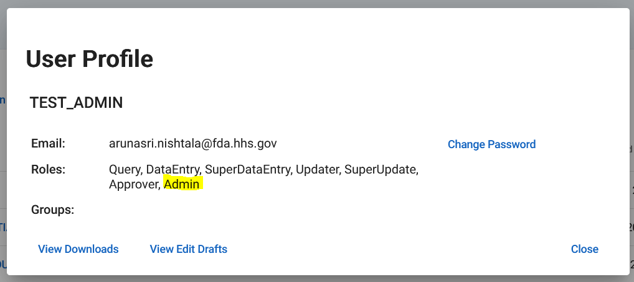

1. **What are the available Admin Module functionalities?**

GSRS administration, authorization also with data checks, imports and management are performed by System Admins.

GSRS data is mostly entered and approved by the respective instance’s data curators, scientists and assigned approver community of the system while the administration of the system is maintained by system Admins. Admins have access to the backend data and can perform certain actions that may otherwise be restricted from other users. Examples and accessibility for admins will be further discussed in the 4th section of this document.

The admin module consists mainly of the following functionalities. Examples and accessibility for each of these will be further discussed in section-4 of this document.

1. Server Status
2. User Management
3. Data Imports
4. CV Management
5. Scheduled Jobs
6. All Files

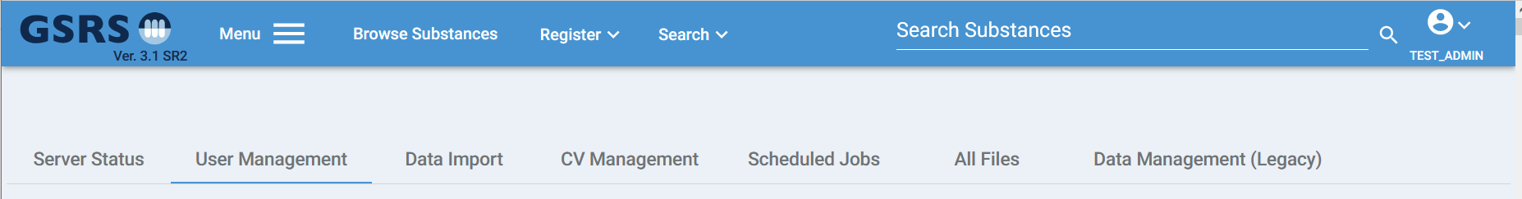

1. **How can we access Admin module?**

Once A user with the ‘Admin’ role logs into GSRS, the admin module can be accessed via the main menu or by clicking on the user profile as shown below.

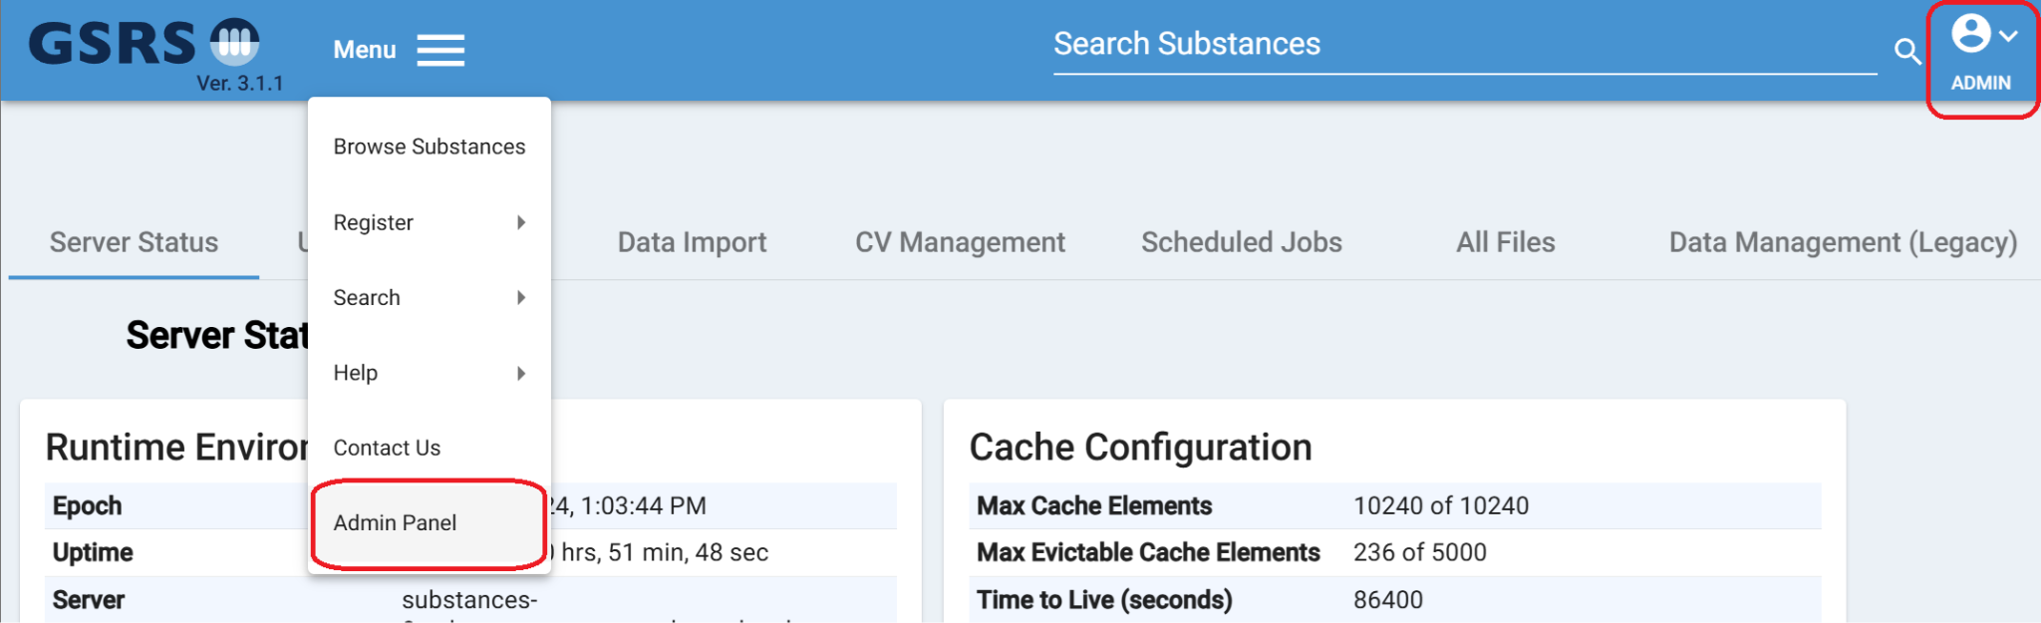

1. **Step by Step User Guide for each functionality:**

### 

### Server Status

The server status page provides various types of information about the server hosting this instance of GSRS. The Runtime environment provides various details on the server uptime, Java version, and useful hardware statistics to get an understanding of current server load based on available CPU and memory resources. The Cache Configuration helps give you information on current data cache availability. The database Information provides useful information on the database level to give you an idea of the current connectivity statistics.

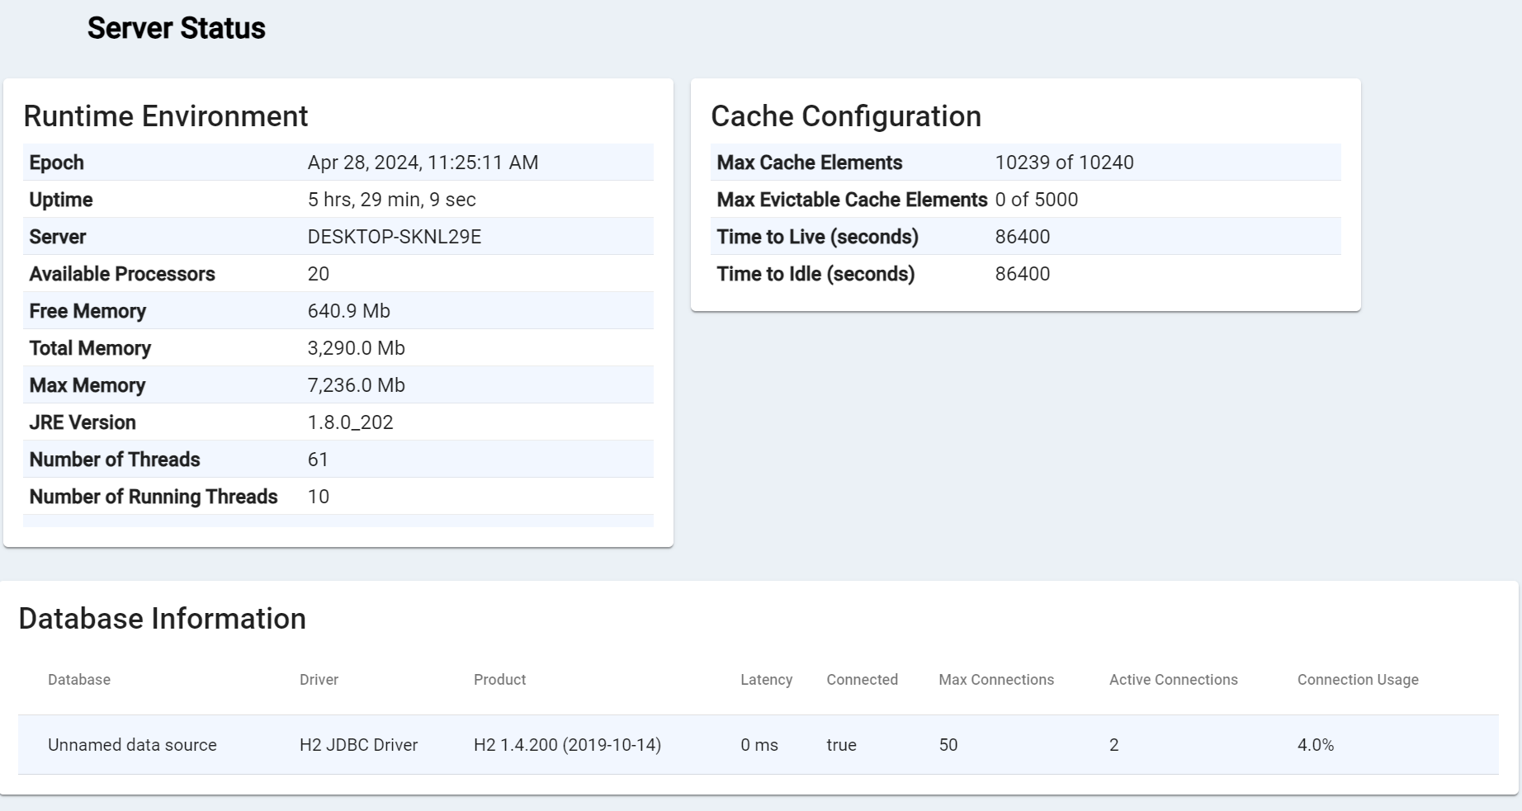

### User Management

User Management allows Admins to view and edit various aspects of users registered in the system. The default view shows a table of all current users. Here users can be searched through marked individually as inactive or marked inactive in bulk. The pencil icon next to the user’s name will allow the admin to edit that user’s profile.

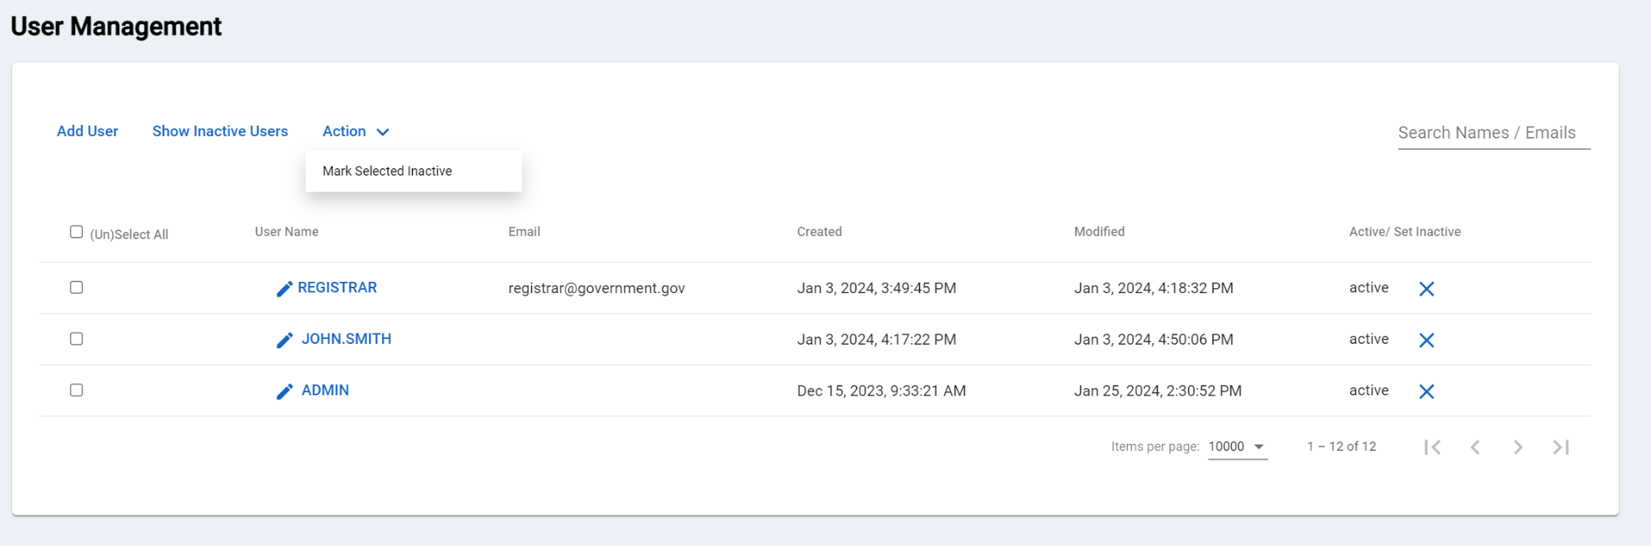

Username, email, current groups and roles, can be reassigned here. Unless turned off in the configuration (see the front end configuration documentation) you can also change or reset a user’s password. Currently the Data Entry roles allow the registration but not editing of new records, updater allows for both editing and registering records, and approver can approve as well as all of the above, but does not have access to the admin menu described in this document.

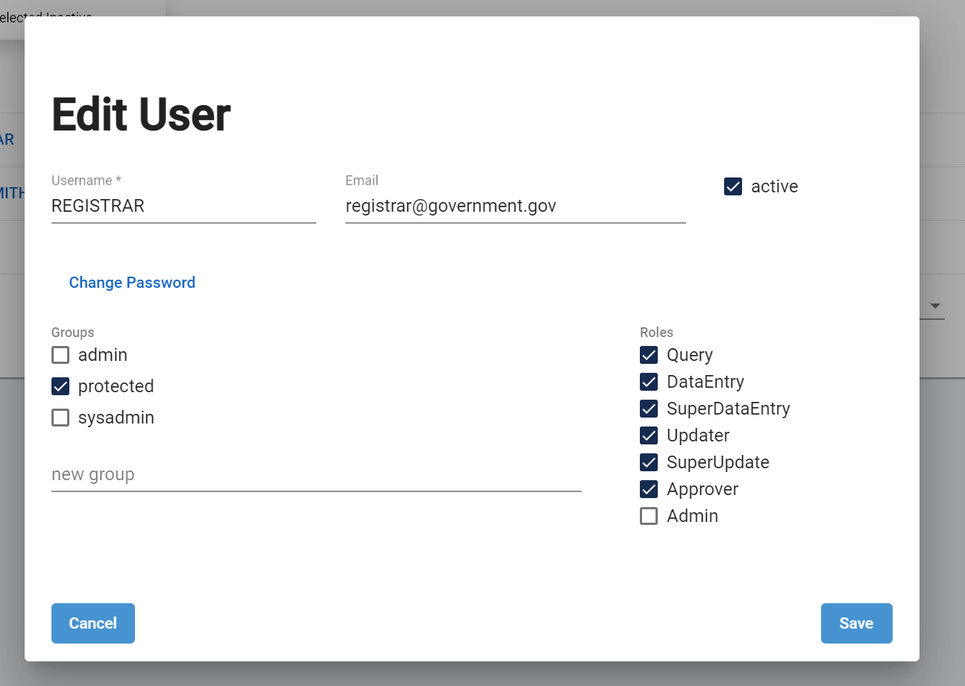

### CV Management

This page allows Admins to access and edit Controlled Vocabularies. A controlled vocabulary is an organized arrangement of words and phrases used to index content and/or to retrieve content through browsing or searching. It typically includes preferred display terms and has a defined scope or describes specific domain variables/parameters.

The screenshot below shows the CV page with the download button and search field. 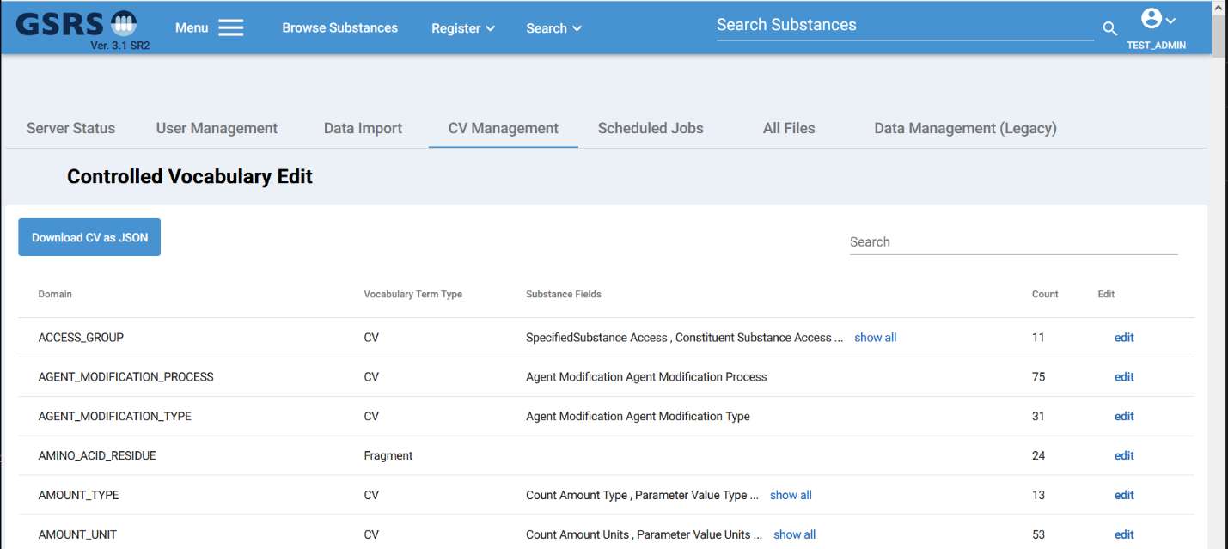

The controlled vocabularies are used frequently throughout GSRS to set display values for certain fields and for the population of dropdown menus in the registration and edit forms of Substances, Applications, etc..

For the Edit forms dropdowns, each list is taken from a respective Domain. To get a better idea of how this works, let’s take the example of ‘Protein type’ in a protein registration form. Figure-1 below shows the dropdown options for ‘Protein Type’. Figure-2 below shows that in the CV module we can search for Protein, find PROTEIN_TYPE as one of the Domain options for this specific search and when we can click on ‘edit’ (Figure-3) to add or edit and save a Protein type CV term.

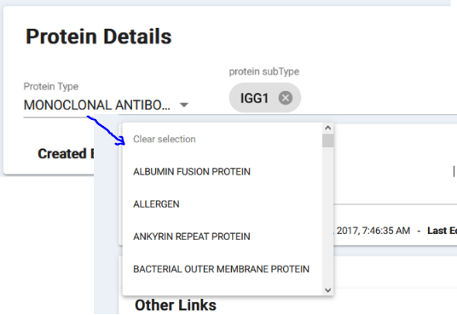

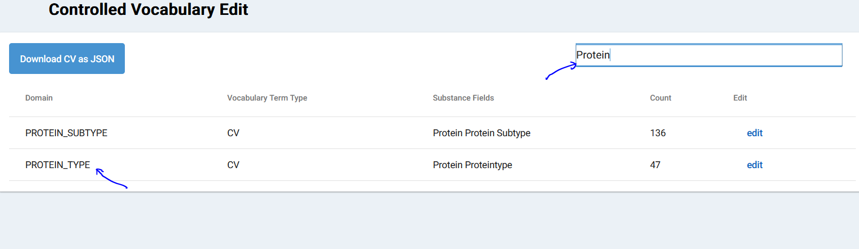

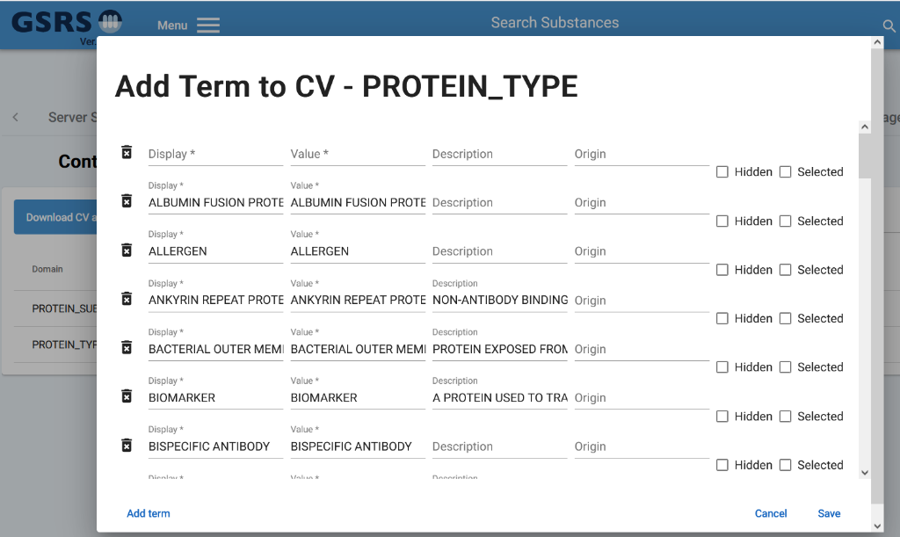

The display value seen on the CV menu is the value shown in the aforementioned dropdown menus and in the substance details and browse results page. The value itself is what is stored as part of the actual substance data. Both are required fields when editing or adding new CV values. The Description field is useful for anyone reviewing or trying to select a particular CV value, and is not currently used outside of this menu. A full list and detailed description of CV domains can be found in the data dictionary on the GSRS wiki. The ‘Hidden’ checkbox marks if the CV value should remain in the vocabulary but not be selectable in the substance edit forms. This is useful for deprecated terms which are still used by substances in the database. Clicking ‘Add Term’ will create an empty row at the bottom of the dialog window. Click ‘Save’ at the bottom to save the changes or additions to a particular domain.  
  
A second and simpler way to add a single entry directly in the edit forms is by selecting the “other (new value)” option at the end of each CV drop-down menu. An “Add” button will then appear which will bring up a dialog to add a new row to that vocabulary as seen below.   
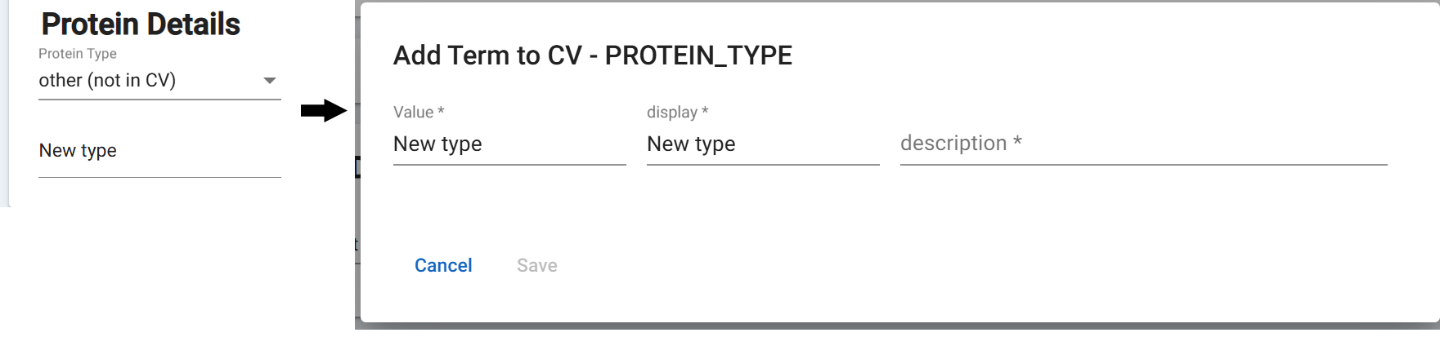

### Data Import

### The Data import tab is a flexible and powerful way of modifying records before they are imported.

This brings you to the second step where you can configure the importer to modify records in the data set as well as preview what those records will look like after import. Bulk changes can be made to the fields before importing depending on the file type and fields present in the uploaded data set. Clicking ‘settings’ will allow you to view and edit basic fields present. Additional references, which will be applied to the substance definition and created names, can be added by clicking the ‘Add Reference’ button. Checking the ‘Ignore Field’ will prevent these properties from being carried over into the next step.

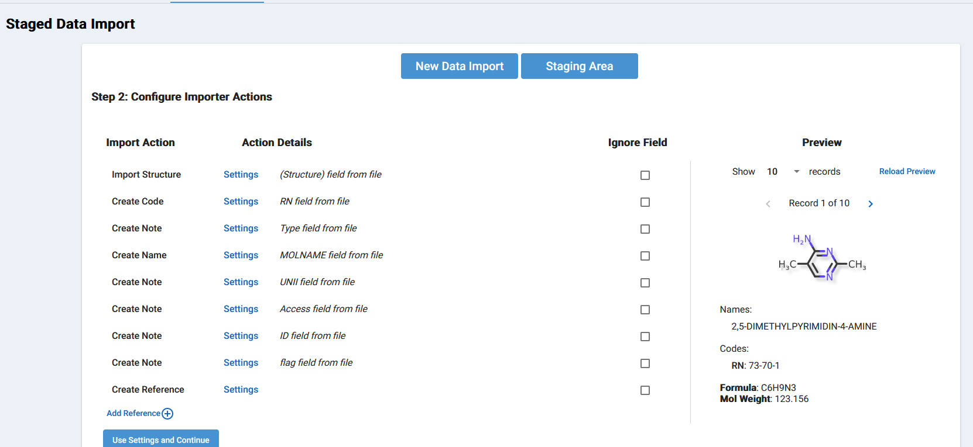

The Import settings menu (above) and Action Settings dialog boxes (below)

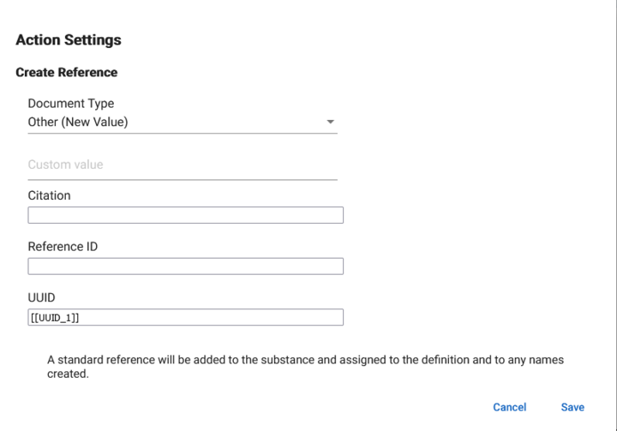

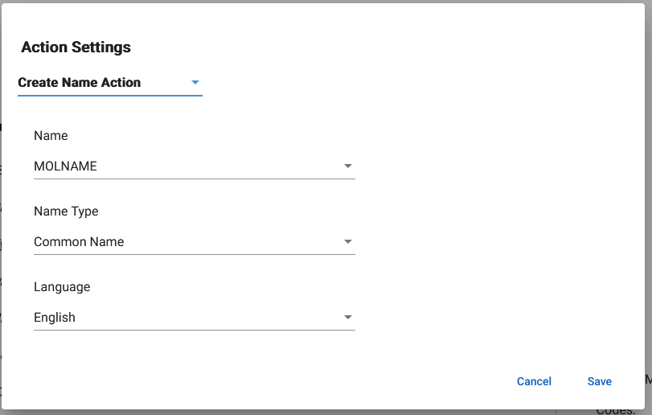

### 

Clicking ‘Use Settings and Continue’ will not add the records directly into the database, but will instead import the records into the staging area where more scrubbing and import options will be available.

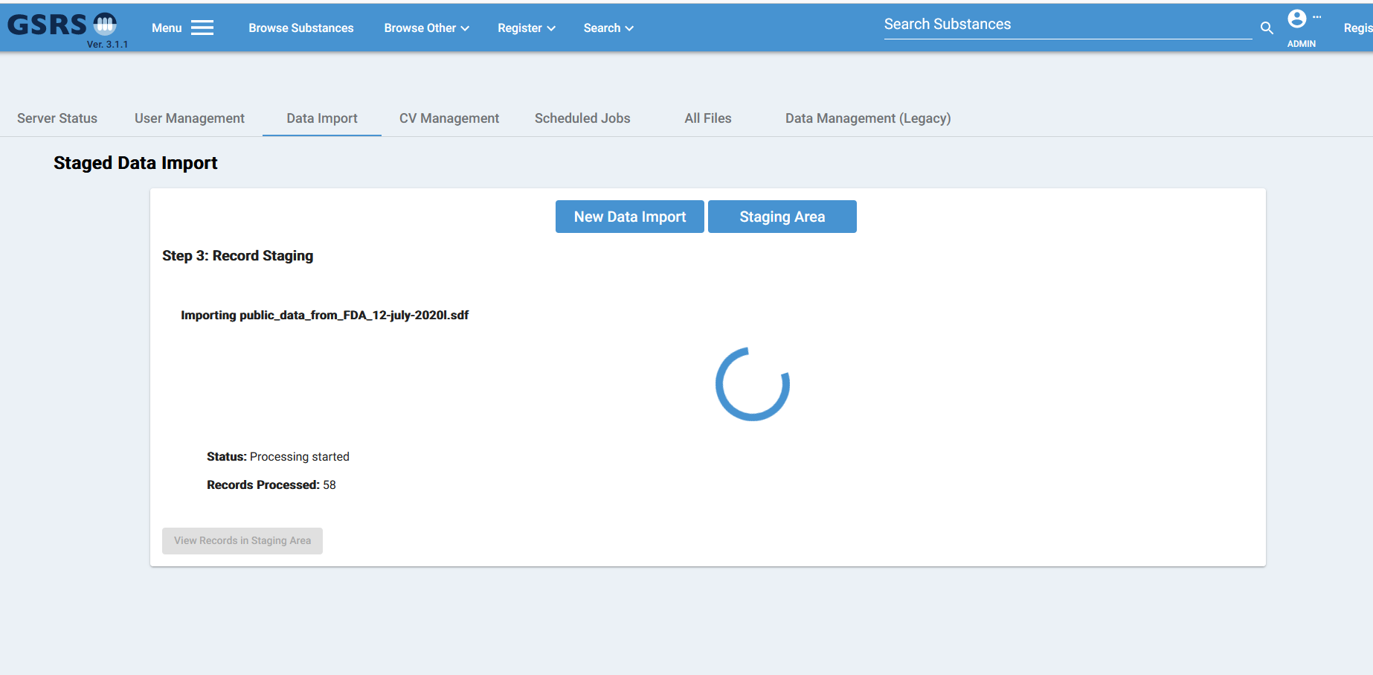

Records in the staging area will persist as database objects across sessions until removed manually. Items in the staging area can be processed individually or in bulk. The ‘Create’ option will allow you to add the record to the main database as a new substance. ‘Edit’ will allow for modifications before creation, and ‘reject’ will remove the record from the staging area.

### 

For Bulk processes, Data cleaning options are available. Further details on what each checkbox does can be viewed by hovering the mouse over the ‘?’ icon.  
  
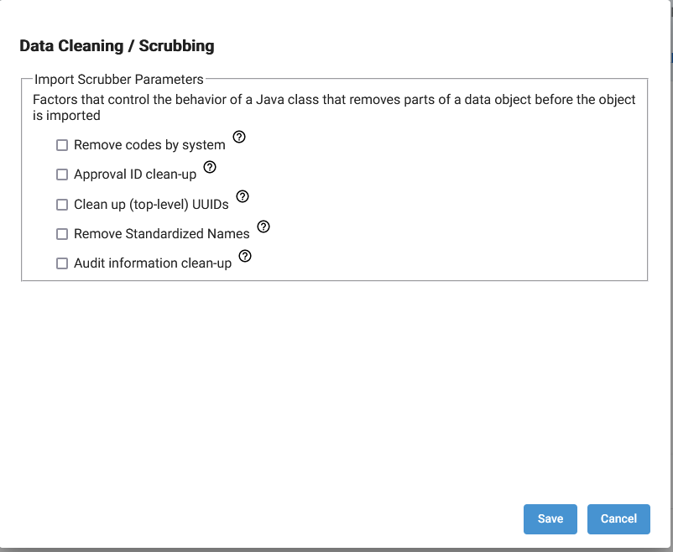

To select records in bulk, you can use the checkbox in the upper right corner of each record’s card, select ‘Select All on Page’ to select those displayed, or ‘Select All Results’ to select all resulting records from the search and facet queries.

Clicking ‘Bulk Actions’ will let you view all selected records and review before any bulk action is taken. Here you also have the option of applying or ignoring the aforementioned data cleaning / scrubbing options. The available actions to be applied to the selected records can be applied by clicking the buttons in the upper right corner. Clicking ‘Save Selections and close’ will close the dialog and save any changes, but will not apply any action.

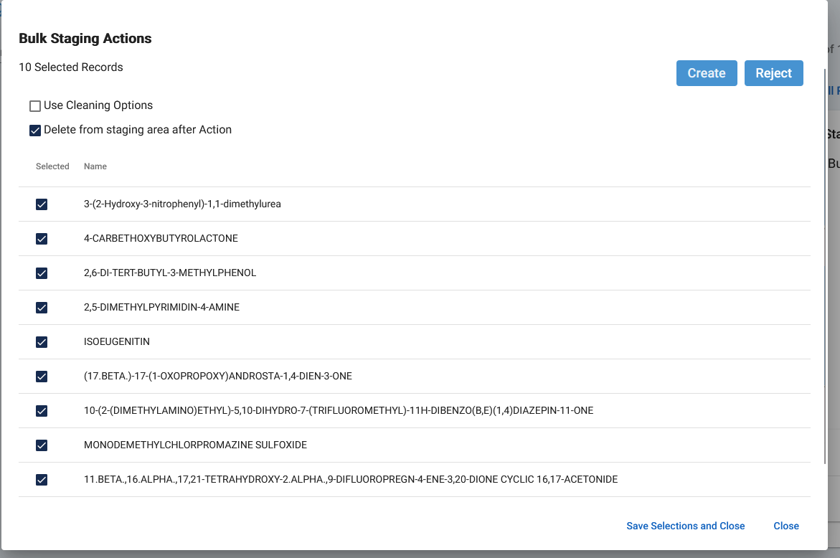

### 

### Data Management (legacy)

The legacy Data management tab contains the data import menu seen in GSRS versions prior to 3.1. This menu allows you to import a .gsrs file with no edits, filters, or modifications of the data prior to import. Click ‘Select File to Upload’ to select a local .gsrs file, then click ‘upload’ to be taken to a screen where you can monitor the progress of the import.  
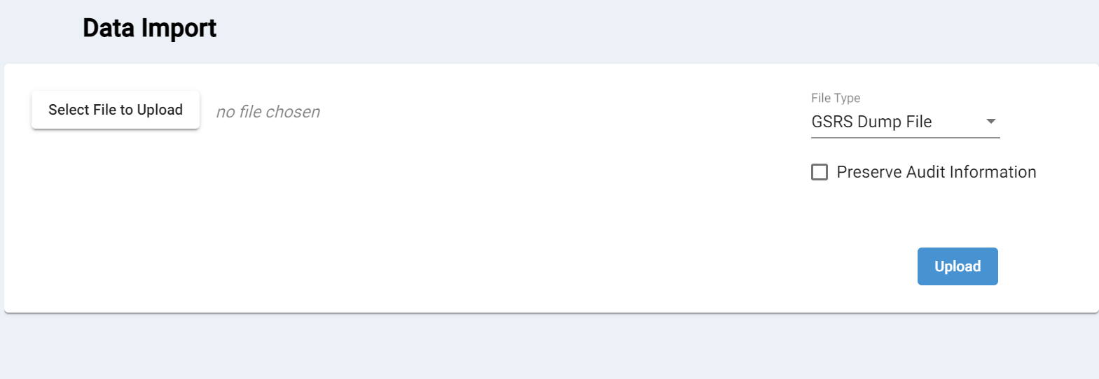

## 

### 

### 

### Scheduled Jobs

Scheduled Jobs are a set of preset database-level tasks which can be launched via the user interface. The majority of these jobs involve either regenerating or recalculating a particular or set of database fields, or creating particular types of log files. Each job is displayed on their own card as seen below with a brief description, status, and chron command line utility notation of the jobs scheduled intervals if set to enabled. A more human readable version is displayed below that, and the ‘(click to enable task)’ button will allow it to run in intervals based on the preset schedule. The ‘Execute now’ button executes the task immediately and only once. Clicking this will give you a status message of the time running and if it is still running or has completed.

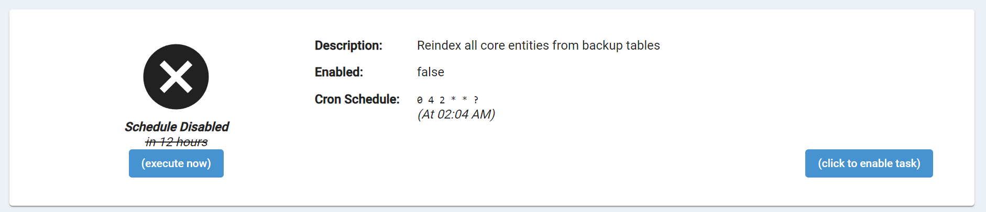

The most important scheduled task to note is the first one shown above, ‘Reindex all core entities from backup tables’ This task can alleviate any issues from bulk data imports and should be run any time the database is completely updated or the data source has been switched for a particular instance.

### All Files

The All files page provides access to the file directory of the instance, and most importantly for debugging, provides the ability to download base level files, and log files without having to access the server directly.  
  
